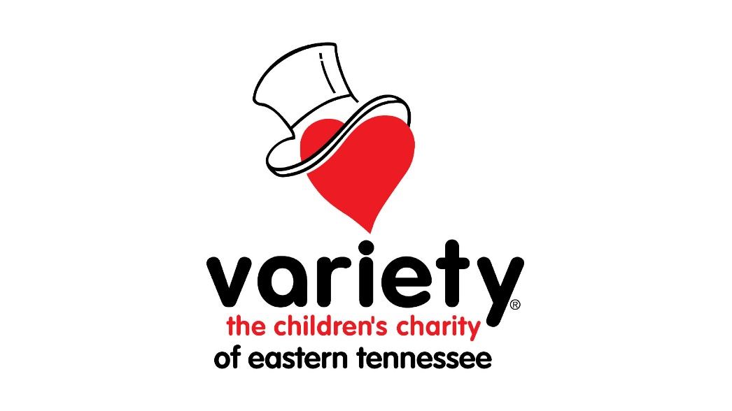

Community Grant Application Packet

EXECUTIVE BOARD OF DIRECTORS
- John Curry
- Jawed Khan
- Warren Sanger
BOARD OF DIRECTORS
- Matt Basford
- Chris Blevins
- Mike Campbell
- Brooks Leboeuf
- Eric Schwarzentraub
- Thomas Song
- Robin Wilhoit
- Ashley Wilson
EXECUTIVE DIRECTOR
- Carol Fusco
101 E. Blount Ave.
Knoxville, TN 37920
(865) 925-9906
carol.fusco@varietytn.org

GRANT PROCEDURE
Variety funds will be distributed once a year. The amount of money available will be determined by the previous year’s fundraising. Variety of Eastern Tennessee reserves the right to make changes to its grant process or its program criteria at any time.
- An initial paper review of applications will be conducted.
- This will be followed by an agency visit.
- The Board may request additional information regarding the applicant and/or its proposed use of funds.

GRANT PHILOSOPHY
Variety of Eastern Tennessee will grant funds only to nonprofit organizations serving the needs of at-risk, disabled, or disadvantaged children in Eastern Tennessee.
Variety of Eastern Tennessee will NOT grant funds to:
- Agencies that serve adults (individuals over 19 years of age).
- For-profit agencies.
- Religious agencies where proselytizing is a part of the service provided.
- Agencies requesting funds for salaries or operational expenses.
- Vehicles.

GRANT ELIGIBILITY REQUIREMENTS
Organizations must:
- Be exempt from taxation under Section 501(c)(3) of the United States Internal Revenue Code.
- Must agree to use the Variety grant only for purposes that are charitable or educational within the meaning of Section 501(c)(3) of the United States Internal Revenue Code.
- Be an equal employment opportunity employer that does not discriminate on the basis of race, religion, marital status, color, national origin, sex, age, or disability.

APPLICATION INSTRUCTIONS - NOTE REQUIRMENT CHANGES FOR 2026
Submission Steps
- Submit an electronic copy (via email) of the application and supporting documentation by the deadline.
- Follow up with a mailed hard copy of the APPLICATION ONLY. Do not send supporting documentation via mail.

Required Documents –
- Cover Letter (on agency letterhead).
- Completed Application.
- Most recent Audit prepared by an independent CPA (if gross revenue is $500,000 or more). Organizations with less revenue can submit a financial statement with an independent CPA’s review. (Email Only)
- Most recent Financial Statements. (Email Only)
- Current list of Board of Directors. (Email Only)
- Most current filed 990 Form. (Email Only)
- 501(c)(3) Determination Letter. (Email Only)
- Explanation of how Variety will be recognized for grant and partnership (e.g., signage, newsletters, photographs). (Email Only)
Deadlines
- March 1st (Disbursements will be communicated in June)
Formatting Guidelines
- Applications must be typed on 8 ½ x 11 paper.
- Use the provided Word document; do not create variations.
- Do not use agency letterhead for the application itself.
- Fasten the application securely with staples or binder clips. Please do not bind.

GRANT APPLICATION QUESTIONS
Organization Information
- Date:
- Name of Organization:
- Contact Person and Title:
- Contact Phone Number:
- Contact Email Address:
- Organization’s Physical Address:
- Mailing Address:
- Phone Number:
- EIN Number:
- Requested Grant Amount:
- Previous Variety Grants Awarded (list years, amounts, and purposes):
Mission and Priorities
- What is your organization’s mission?
- What is the purpose of your organization?
- What services does your organization provide?
Program Details
- Describe the program for which you are applying. Include specific details.
- How will your organization use the requested funding?
- If requesting funds for equipment, materials, or supplies, describe the items and include price quotes on vendor stationery.
Community Served
- How many children will this specific grant serve?
- How many children in total does your organization currently serve in total?
- What are the ages of the children this grant will serve?
- What East Tennessee counties do the program serve? (List schools if applicable.)
- Are there other organizations providing similar services? If yes, list them.
- Describe the program’s value to the community.
- Has independent research outlined the need for this program? If so, describe.
- What are the financial eligibility requirements for the children this grant will serve?
Human Resources
- Number of employees and their qualifications (including titles).
- Number of volunteers.
- How many paid employees does your organization have?
Program Management
- How will your organization evaluate the program’s effectiveness?
  - Short-term results:
  - Medium-term results:
  - Long-term results:
- Describe the specific results or milestones expected from Variety funds.
- Provide examples of how Variety will be recognized for the grant and partnership.
Financial Resources
- List the organization’s corporate, foundational, or government funding sources. (Complete Sources of Funding Form)
- Describe local fundraising campaigns or events (including amounts raised).
- If Variety funds have helped leverage other resources, describe them.
- If applicable, provide details of Regal Foundation grants received.
Final Notes
- Include any additional information about your organization or proposed grant use.

BUDGET FORM - *Note, Variety will not grant funds for salaries or overhead.
Organization Information
- Name of Organization: _______________________
- Fiscal/Calendar Year: _____ to _____
- EIN Number: ____________________________
Expenses: *Note, Variety will not grant funds for salaries. | (A)  Variety Program/Project Requested Funding | (B)  All Other Programs | (C)  Total Organizations Operating Budget (A+B=C)
- Personnel Costs * | $ | $ | $
Employees (No.___)
Benefits:
Other:
- Non-Personnel Costs
Space
Equipment
Supplies for programing
Supplies other
Telephone
Travel
Training
Capital Expenditures
Insurance
Audit
Contract Services
Dues and Fees
Transportation
Other (include detail)
Other (include detail)
Other (include detail)
- Total Costs | $ | $ | $

SOURCES OF FUNDING FORM
Sources of Funding | (A)  Variety Project Requesting Funding For | (B)  All Other Programs | (C)  Total Organizations Operating Budget (A+B=C)
1. Variety grant requested | $ | $ | $
2.
3.
4.
5.
6.
7.
8.
9.
10.
11.
12.
13.
14.
15.
16.
17.
18.
19.
20.
Total Revenue | $ | $ | $

GRANT AGREEMENT
If granted Variety funds, the organization agrees to:
- Carry out the project described in the application.
- Not use funds for salaries or operational expenses.
- Submit a progress report no later than one year after receiving funds.
- Recognize Variety for the grant and partnership.
- Return any unspent funds to Variety of Eastern Tennessee.

________________________________
Date

________________________________

Name of Applicant

________________________________

Signature of Program Director

________________________________
Signature of Board Member

________________________________
EIN #

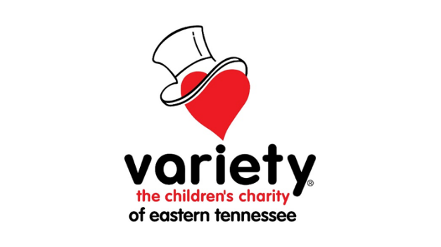

PROGRESS REPORT
- Organization Name:

- Date:

- Amount of Funding Received:

- Number of Individuals Impacted:

- One-sentence description of the project:

- Progress to date:

- How the Variety donation expanded the organization’s mission:

- Metrics demonstrating the impact of the donation:

- Additional thoughts or insights (attach pictures if applicable).

